**Business Question and Visualization Report**

|  |  |
| --- | --- |
| Date | 24 June 2025 |
| Team ID | XXXX |
| Project Name | Predicting plant growth stages with environmental and management data using power bi |
| Maximum Marks | 5 Marks |

Visualization development refers to the process of creating graphical representations of data to facilitate understanding, analysis, and decision-making. The goal is to transform complex datasets into visual formats that are easy to interpret, enabling users to gain insights and make informed decisions. Visualization development involves selecting appropriate visual elements, designing layouts, and using interactive features to enhance the user experience. This process is commonly associated with data visualization tools and platforms, and it plays a crucial role in business intelligence, analytics, and reporting

**Business Questions and Visualisation**

The process involves defining specific business questions to guide the creation of meaningful and actionable visualizations in Power BI. Well-framed questions help in identifying key metrics, selecting relevant data, and building visualisation that provide insights.

**Sample**

1. **Which fertilizer type resulted in the most growth milestones?**
   * *Visualization*: Doughnut Chart of Growth Milestone by Fertilizer Type
   * *Screenshot of visualisation*

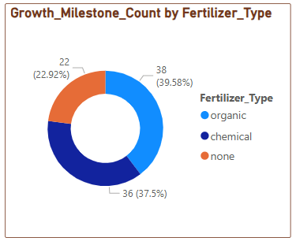

1. **Which humidity level had the highest average humidity?**
   * *Visualization*: Bar Chart of Average Humidity by Humidity Level
   * *Screenshot of visualisation*

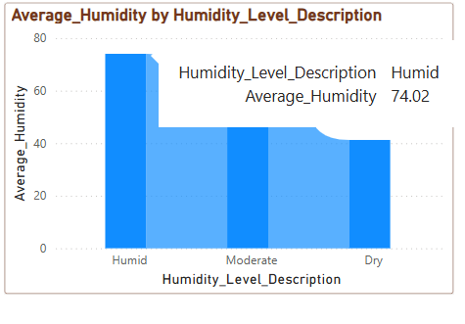

1. **Which soil type led to the highest growth milestones?**
   * *Visualization*: Decomposition tree of Growth Milestone Count by Soil Type.
   * *Screenshot of visualisation*

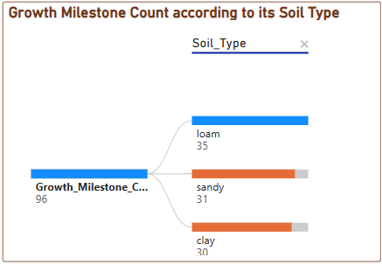

1. **What condition causes temperature to increase most?**
   * *Visualization*: Key Influencer for Temperature Increase
   * *Screenshot of visualisation*

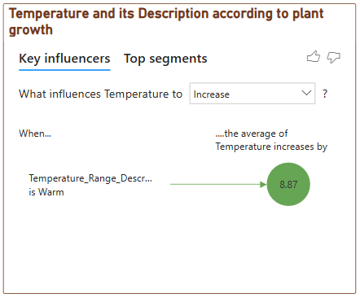

1. **Which soil type receives the most sunlight on average?**
   * *Visualization*: Pie Chart of Sunlight Hours by Soil Type
   * *Screenshot of visualisation*

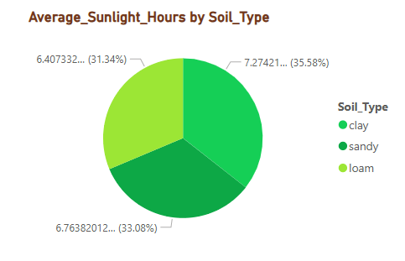

1. **Which soil type receives the most sunlight on average?**
   * *Visualization*: Line Chart of Growth Milestone Count by Humidity Level
   * *Screenshot of visualisation*

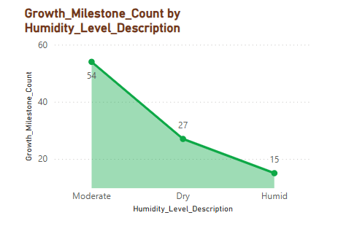

1. **Which water frequency had the highest growth milestone percentage?**
   * *Visualization*: Tree map of Growth Milestone % by Water Frequency
   * *Screenshot of visualisation*

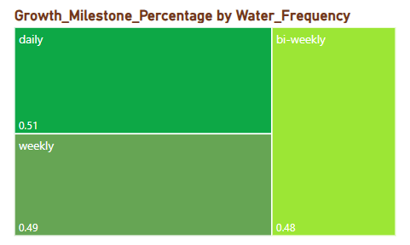

1. **What is the total growth milestone count?**
   * *Visualization*: Gauge Chart of Total Growth Milestone Count
   * *Screenshot of visualisation*

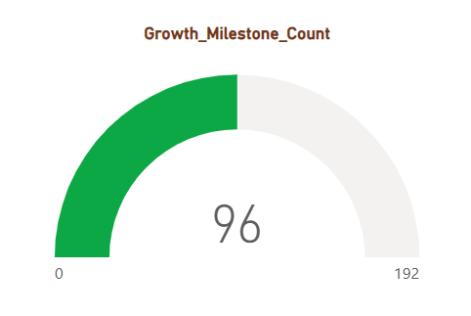

**Note:** Min 8 business question and visualisations Required inform of above